Credit Card Fraud Detection
Detecting fraudulent transactions on a highly imbalanced dataset
An end-to-end machine-learning case study
EDA → Feature Engineering → Model Comparison → Tuning → SHAP → Business Impact
Muhammad Tahir Riaz
github.com/triaz-malik/Machine-Learning

Executive Summary
We built a fraud-detection system on 1.85 million card transactions where only 0.58% are fraudulent. Because the data is so imbalanced, accuracy is meaningless — a model that predicts “never fraud” scores 99.4% accuracy while catching zero fraud. We therefore optimised recall, precision, and PR-AUC instead.
Moving from a linear baseline to a tuned XGBoost model lifted PR-AUC from 0.18 to 0.88. At a business-chosen operating point the model catches 90% of fraud while flagging only 0.35% of legitimate transactions for review — turning roughly 5,800 caught frauds (baseline) into ~9,000 per 10,000 fraud cases.

1. Business Problem
Banks must decide, in real time, whether to approve or block each card transaction. Fraud is rare but expensive, and the cost structure is asymmetric:
- Missed fraud (false negative): direct financial loss and chargebacks.
- False alarm (false positive): manual-review cost and customer friction.
The objective is to maximise the share of fraud caught (recall) while keeping false alarms low enough that the review team can cope (precision).

2. The Input Data
Dataset: Simulated credit-card transactions (Sparkov). Pre-split into train and test files.
Split | Transactions | Fraud (rate)
Train | 1,296,675 | 7,506 (0.579%)
Test (held-out) | 555,719 | 2,145 (0.386%)

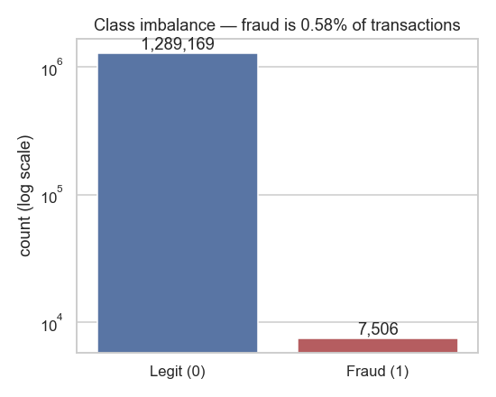
Figure 1 — Extreme class imbalance: fraud is 0.58% of all transactions (log scale).

Features used by the model
From the raw columns we engineered 23 features. PII and identifiers were dropped to prevent the model memorising individuals, and leakage / non-predictive columns were removed.
Feature group | Details / rationale
Amount | amt and log_amt — the single strongest signal.
Time of day | hour and is_night (22:00–03:59), where fraud concentrates.
Calendar | day_of_week, is_weekend.
Demographic | age (from dob), gender, log city population.
Merchant category | 14 categories, one-hot encoded.
Dropped — PII | first, last, street, trans_num, raw cc_num.
Dropped — leakage | unix_time (duplicates timestamp).
Dropped — no signal | home–merchant distance (both classes ~76 km; verified, not assumed).

3. Exploratory Findings
Profiling the full training set surfaced three dominant fraud signals, later confirmed by the model.
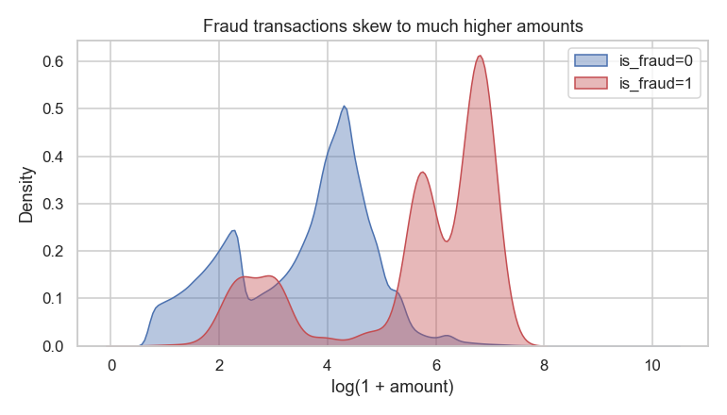
Figure 2 — Fraud transactions skew to far higher amounts (mean $531 vs $68).
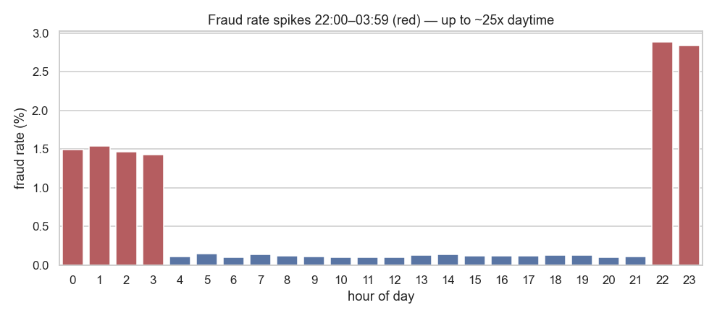
Figure 3 — Fraud is a night-time phenomenon: rates spike 22:00–03:59, up to ~25× daytime.
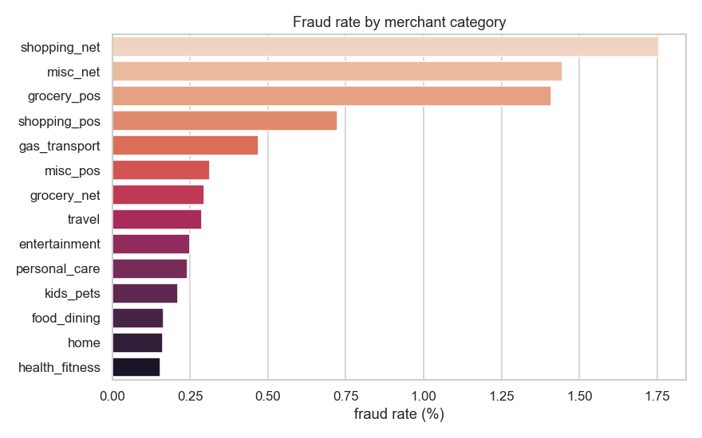
Figure 4 — Online categories (shopping_net, misc_net) carry the highest fraud rates.

4. Models
We trained an explainable baseline, then progressively stronger models — each evaluated on the same held-out test set with the same metrics. Imbalance was handled with class weights (LogReg, RandomForest) and scale_pos_weight (XGBoost).
Model | PR-AUC | ROC-AUC | Precision | Recall | F1
Logistic Regression (baseline) | 0.184 | 0.964 | 0.29 | 0.58 | 0.38
Random Forest | 0.872 | 0.997 | 0.90 | 0.75 | 0.81
XGBoost | 0.873 | 0.998 | 0.90 | 0.76 | 0.83
XGBoost (tuned) | 0.880 | 0.998 | 0.90 | 0.90 | —
Recall for the tuned model is at the business threshold (Section 6); others at best-F1.
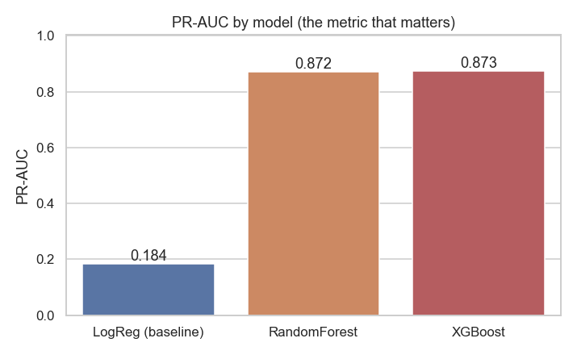
Figure 5 — PR-AUC leaps 0.18 → 0.87 moving from linear to tree models.
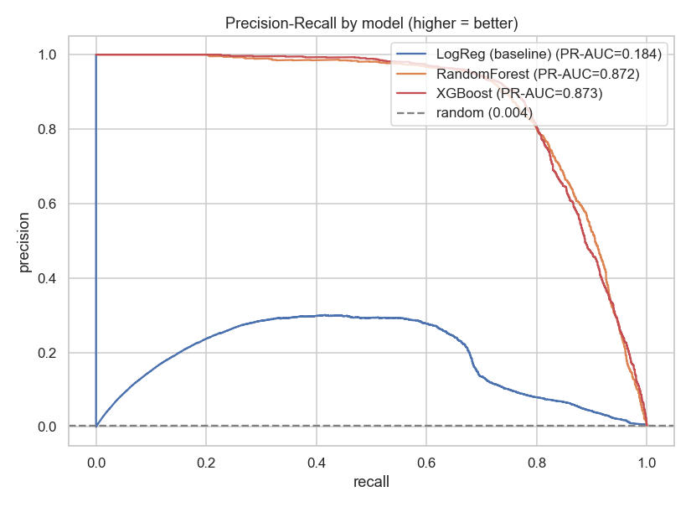
Figure 6 — Precision-recall curves: tree models dominate across the whole range.
Why trees win: fraud lives in interactions — high amount AND night AND an online category. A linear model cannot represent these; gradient-boosted trees can.
Tuning: a PR-AUC-scored RandomizedSearchCV selected max_depth=6, learning_rate=0.05, n_estimators=600, subsample=0.7, gamma=1 (CV PR-AUC 0.90).

5. Explainability (SHAP)
The model is auditable, not a black box. SHAP confirms the EDA story: amount and night-time dominate, followed by hour and online categories.
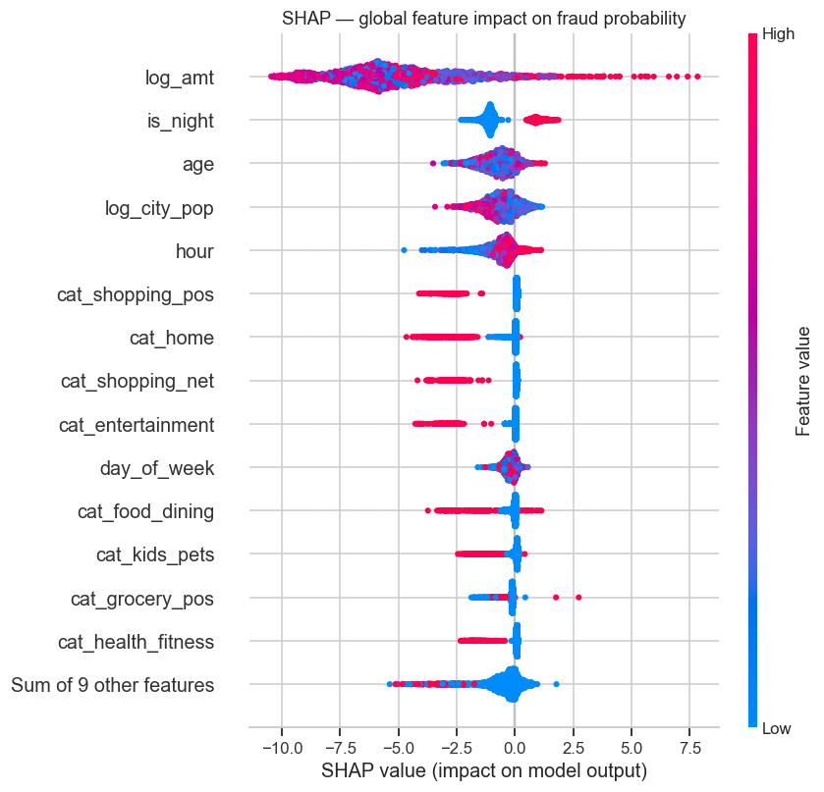
Figure 7 — Global SHAP: log_amt and is_night are the top drivers of fraud probability.
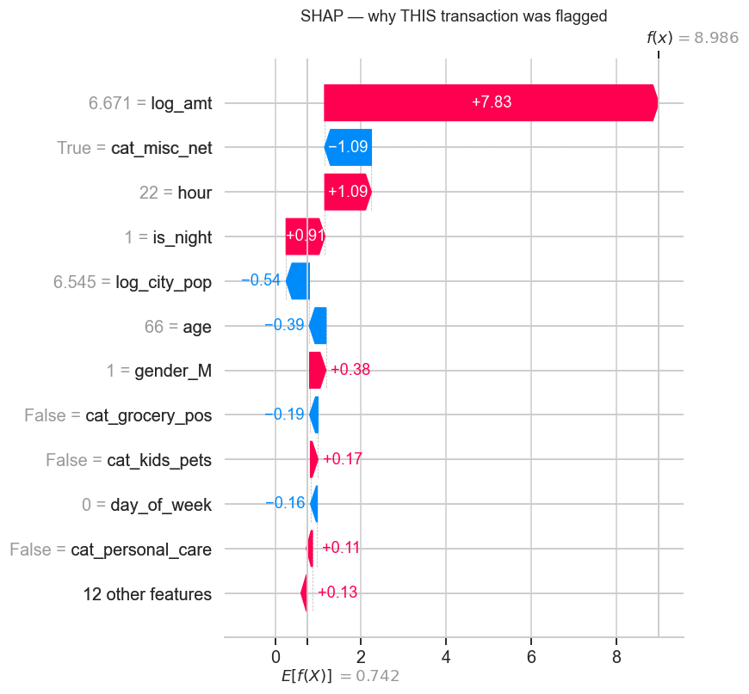
Figure 8 — Local SHAP: why one specific transaction was flagged as fraud.

6. Business Value
Bank policy: catch at least 90% of fraud. We pick the highest-precision probability threshold that meets that recall (threshold = 0.80) and read off the operational trade-off on the held-out test set.
Outcome at the 90%-recall threshold | Result
Frauds caught (true positives) | 1,931 of 2,145 — 90.0%
Frauds missed (false negatives) | 214 — 10.0%
False alarms sent to review | 1,910 of 553,574 legit — 0.35%
Precision (flags that are real fraud) | 50.3%

Translated to scale — per 10,000 fraud cases:
- Baseline Logistic Regression (58% recall): catches ~5,840, misses ~4,160
- Tuned XGBoost (90% recall): catches ~9,000, misses ~1,000
Net impact: missed fraud falls by ~75%, while only 0.35% of legitimate customers experience a review — a strong recall gain at a manageable false-alarm cost.

7. Conclusion & Reproducibility
The project demonstrates the full lifecycle: grounded EDA, leak-safe feature engineering, an iterative model ladder evaluated with the right metrics, hyperparameter tuning, SHAP explainability, and a business-driven operating point.
- Notebooks: 01 EDA • 02 features + baseline • 03 model comparison • 04 tuning + SHAP + threshold.
- Reusable code: src/features.py (leak-safe feature pipeline).
- Repository: github.com/triaz-malik/Machine-Learning
Note: the raw CSVs (~500 MB) are not committed; download from the Kaggle “Credit Card Transactions Fraud Detection” dataset to reproduce.

